SPECIAL EVENT PRICING
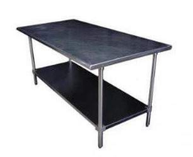  S/S Food Prep Table  (6’L x 36” W)  $98.18++ | 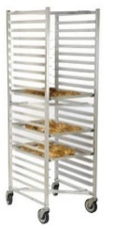  Sheet Pan Rolling Rack $57.07++  Fits 20 pans – 18”x26” $4.31++/pan | 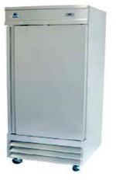  S/S Single Door Refrigerator  $303.66++ | 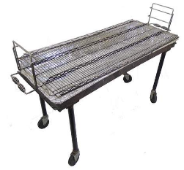  Propane Grill  SUMMER FESTIVALS 2023  $314++  100lb Propane Tank  $135.84++ | 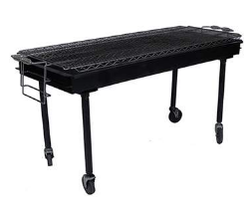  Charcoal Grill  (Does not include charcoal)  $98.18
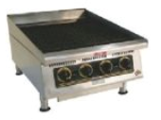  Charbroiler  $216.30++  100lb Propane Tank  $135.84++ | 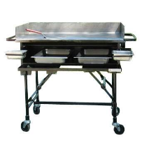  90k BTU Propane Griddle  $97.02  100lb Propane Tank  $135.84++ | 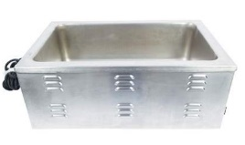  8qt S/S Rectangular Electric Chafer  $47.99++  Food Pan 2”D  $6.83++  Food Pan 4”D  $7.04++ | 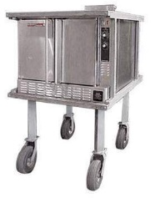  75k BTU Convection Oven  $393.91++  100lb Propane Tank  $135.84++ | 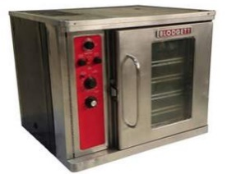  Electric Convection Oven  $258.04++
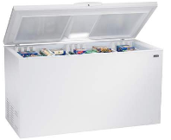  Freezer Chest 14 Cu. Ft.  $162.33++ | 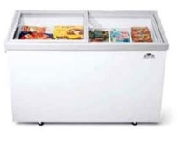  Glass top Freezer Chest 17 Cu. Ft.  $446.25++ | 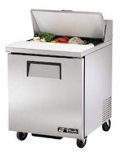  Sandwich Prep Refrigerator  $251.84++ | 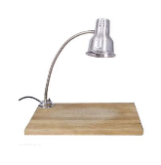  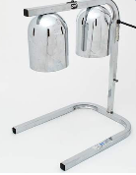  S/S Dual Cone Heat Lamp  $38.80++  S/S Single Heat Lamp w/ Board  $66.20++ | 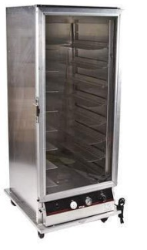  18 Shelf Electric Warming Cabinet  $337.94
Visit our website for additional equipment: Marqueerents.com
For further information or to receive a quote, please reach out to:
Maddie Rand | Account Executive
MRand@marqueerents.com
C: 630-777-9062

